

**Problem Statement**

Develop a model/software which will help students to assess mental health of students, build methods to find out and provide solution for the improvement

**Organisation**

Ministry Of Education

**PS NUMBER**

SIH1433

**Domain Bucket**

Smart Education

**Team Name – Software Name**

MindValley - UMatter

**IDEA DESCRIPTION**

A software which helps students assess their mental health and provides them personalized solutions, based on the assessment, for their improvement.

The focus is on applying the international standard and best-known practices of mental well-being to create a student focused web app that addresses each student’s everyday problems and helps them to solve it.

By building a reliable online mental health assessment platform, with all the student focused features and resources, we aim to empower each student and help them take control of their mental well-being so that they can guide through life’s challenges with a positive attitude and lead a successful and fulfilled student life, as well as a well-balanced adult life.

**FEATURES OF THE SOFTWARE**

* A quick self-assessment test to determine the present mental state of the student
* Personalized solutions based on the assessment results, solutions thus provided are covered below
* Immediate crisis supports in the form of hotlines, web-chat and nearest emergency services contact information
* Self-help resources in the form of guided-mindfulness sessions, eBooks, articles, professional blogs, calm walkthrough videos and coping strategies
* Suggested mental health practices and habits to include in your day, like gratitude, physical exercise, and meditation, for student’s overall well-being
* A common LinkedIn-like community for mental health experts and professionals on which users can
* Peer Support in the form of forums, overseed and maintained by medical professionals
* Option to view the nearest mental health professionals near you.
* Personal journalling tool and Student Mood Tracker which enables the student to track his/her mental health
* Connecting local medical professionals and those in need through a common platform for effective treatment and well-being
* An AI ML based Chatbot will also be included, which will learn more and more about the student with time, and will serve as a personal go-to assistant during any mental turmoil.
* According to the assessment results, suitable music genre, Spotify playlists, and even movies will be recommended to immediately uplift the mood of the student.
* Man Ki Baat Official Videos and Outputs, and National Mental Health Program
* Registration for nearby UMatter events, workshops, options for attending them online and offline both
* Having a special theme every month to raise awareness about each domain of mental health

**ADVANTAGES OF THE SOFTWARE**

* Increased Awareness –

Such a website can provide valuable information about various mental health conditions, reducing stigma, and promoting understanding.

* Accessible Information –

People can self-assess and implement recommended solutions 24/7, which can be especially helpful during times of crisis or when professional help is not immediately available.

* Early Intervention –

The tracking feature can help users identify early warning signs of deteriorating mental health. This can facilitate timely intervention and support from mental health professionals or loved ones.

* Community Support –

The sense of community of people facing common problems can provide emotional support and reduce feelings of isolation.

* Reduction in Healthcare Costs –

By helping individuals manage their mental health proactively, healthcare costs will be reduced significantly as compared with untreated or poorly managed mental health conditions.

* Education and Prevention –

The website will also serve as an educational platform, teaching users about risk factors, signs of mental health disorders, and preventive measures they can take.

Top of Form

**TECH STACK**



HTML 5, Bootstrap 5, CSS 3 and JavaScript 5 inside React Framework for a User-friendly and interactive front-end.

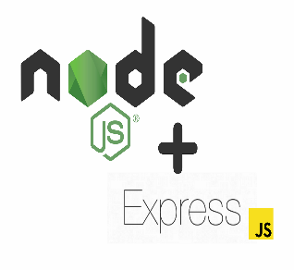

MongoDB as the database and Express-NodeJS constitute the backend of the website

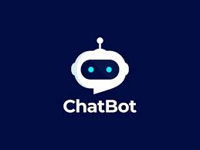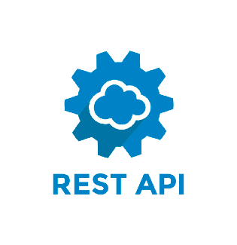

Rest API and Chatbot services will be used to enhance the overall speed and usefulness of the website

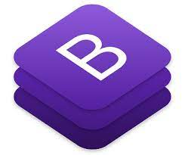

**Existing Examples**

Many online websites and apps exist as a partial solution for the problem stated above. The following come closest to becoming a solution –

* NAMI.org (National Alliance on Mental Illness)
* MHA.org (Mental Health America)
* Psychiatry.org
* ClinicalPartners.org
* TalkSpace.com
* Moodkit (No professional help feature)
* Headspace and iBreathe (Simply Meditation In the name of mental health)
* Companion app – (Tracking feature only, no solutions)

But none of these offers all of the features at once!

**Their Shortcomings**

* Instead of being customer focused, they have just become awareness and health-data blogs
* None of them are integrated
* No self-assessment and personalized solutions based on the assessment results.
* Students section fails to address the student specific issues, like handling the stress and pressure of competitive exams, placement pressure, early drug abuse, etc.

**Revenue Generation**

In this day and age, it is absolutely certain that our completely preoccupied and busy lifestyles have created the essential need of Stress Management and monitoring-maintaining our Mental Well Being.

The absence of a common platform for connecting local medical professionals with those in need, and which provides a 24/7 user focused solution service that is personalized based on the mental health assessment, presents a wonderful opportunity for a startup.

In particular, the following opportunities can contribute to revenue generation for the startup –

* Introduction of an extra fees for connecting the medical professional and the customers
* Offering an optional premium subscription to the customers which will provide them more user-focused resources, enhanced assessment results and recommendations from other domains
* An AI Chatbot subscription can be introduced for the use of AI and ML powered chatbot which will act as a personal talk-to friend. The chatbot will get more and more personalized each customer in a unique way as it learns more and more about them.
* Paid courses can be provided on the website about the entire topic of Mental health.

Due to the tight time constraint, third-party APIs will be used for building a prototype, but immediately after qualification, personalized APIs and Chatbots will be built having all the student-oriented features missing in the third-party products. Existing ChatGPT 3.5 model may be retrained on mental health issues and their diagnoses to build a strong Chatbot.

**How we’re different**

1. All in one, integrated platform that provides the required features at one place
2. An ML based personal Chatbot that learns the conditions and requirements of each user and provides personalized solutions.
3. Providing an open community for people facing the same problems and challenges to come together and have a chance to help each other.
4. Helps identify the conditions being faced by the user
5. Student focused

**Solutions of the Test**

1. The particular communities of people, overseed by respective medical health professional, which focuses on the assessed being problem faced by the user
2. The contact information of the Mental Health professional specialising in the problem so detected, for reference purposes.
3. The official prescribed and expert verified treatment for the problem being faced by the user.
4. Multimedia recommendations : Suggested music playlists, movies and more to immediately uplift your mood.

**Resources**

1. Blogs, Articles, (Hear it from them) Experience of people who went through mental health issues, Meditation and Calm, Recommended Books,

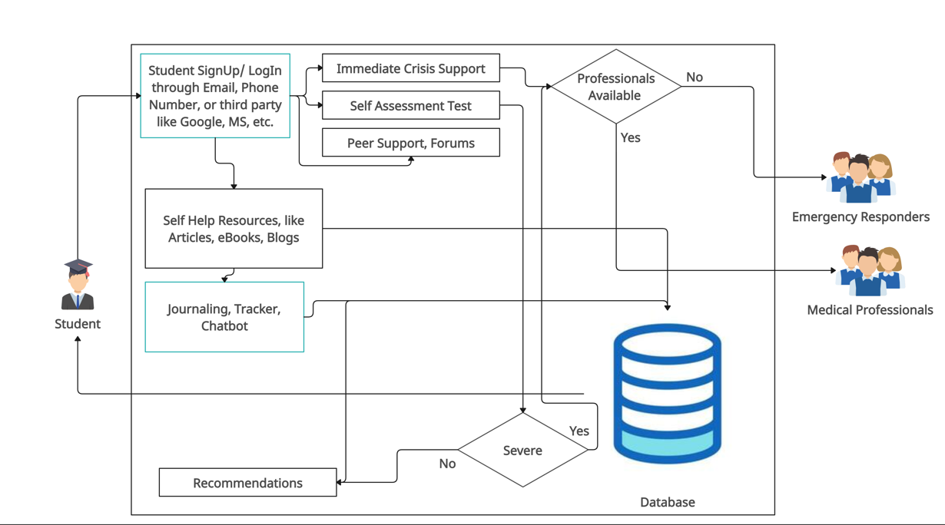**Flow Chart**